**Types of Graphs and Charts and Their Uses**

If you are wondering what are the different **types of graphs and charts**,their uses and names, this page summarizes them with examples and pictures.

Every type of graph is a visual representation of data on diagram plots (ex. bar, pie, line chart) that show different types of graph trends and relationships between variables.

Although it is hard to tell what are all the types of graphs, this page consists all of the common types of statistical graphs and charts (and their meanings) widely used in any science.

**1. Line Graphs**

A line chart graphically displays data that changes continuously over time. Each line graph consists of points that connect data to show a trend (continuous change). Line graphs have an x-axis and a y-axis. In the most cases, time is distributed on the horizontal axis.

Uses of line graphs:

* When you want **to show trends**. For example, how house prices have increased over time.
* When you want **to make predictions** based on a data history over time.
* When **comparing** two or more different variables, situations, and information over a given period of time.

Example:

The following line graph shows annual sales of a particular business company for the period of six consecutive years:

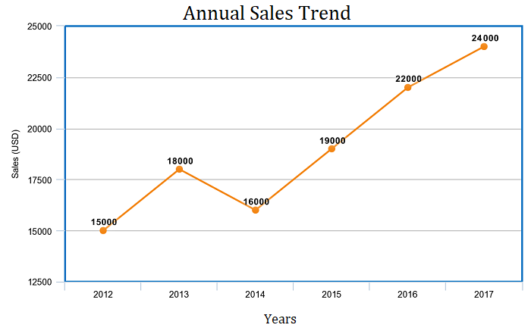

Note: the above example is with 1 line. However, one line chart can compare multiple trends by several distributing lines.

**2. Bar Charts**

Bar charts represent categorical data with rectangular bars (to understand what is categorical data see [categorical data examples](http://intellspot.com/categorical-data-examples/)). Bar graphs are among the most popular types of graphs and charts in economics, statistics, marketing, and visualization in [digital customer experience](http://intellspot.com/digital-customer-experience/). They are commonly used to compare several categories of data.

Each rectangular bar has length and height proportional to the values that they represent.

One axis of the bar chart presents the categories being compared. The other axis shows a measured value.

Bar Charts Uses:

* When you want to display data that are grouped into **nominal or ordinal categories** (see [nominal vs ordinal data](http://intellspot.com/nominal-vs-ordinal-data/)).
* **To compare data** among different categories.
* Bar charts can also show **large** **data changes** over time.
* Bar charts are ideal for visualizing the distribution of data when we have more than three categories.

Example:

The bar chart below represents the total sum of sales for Product A and Product B over three years.

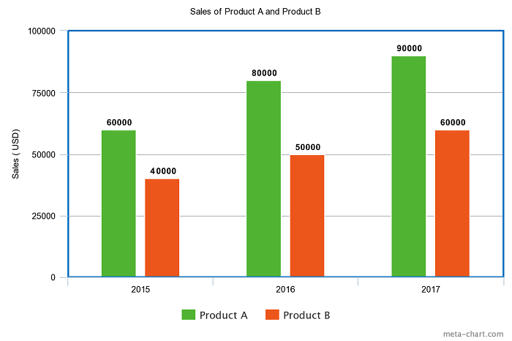

The bars are 2 types: vertical or horizontal. It doesn’t matter which kind you will use. The above one is a vertical type.

**3. Pie Charts**

When it comes to statistical types of graphs and charts, the pie chart (or the circle chart) has a crucial place and meaning. It displays data and statistics in an easy-to-understand ‘pie-slice’ format and illustrates numerical proportion.

Each pie slice is relative to the size of a particular category in a given group as a whole. To say it in another way, the pie chart brakes down a group into smaller pieces. It shows part-whole relationships.

To make a pie chart, you need a list of categorical variables and numerical variables.

Pie Chart Uses:

* When you want to create and **represent the composition** of something.
* It is very useful for displaying **nominal or ordinal** categories of data.
* To **show percentage** or proportional data.
* When **comparing areas of growth** within a business such as profit.
* Pie charts work best for displaying data for**3 to 7** categories.

Example:

The pie chart below represents the proportion of types of transportation used by 1000 students to go to their school.

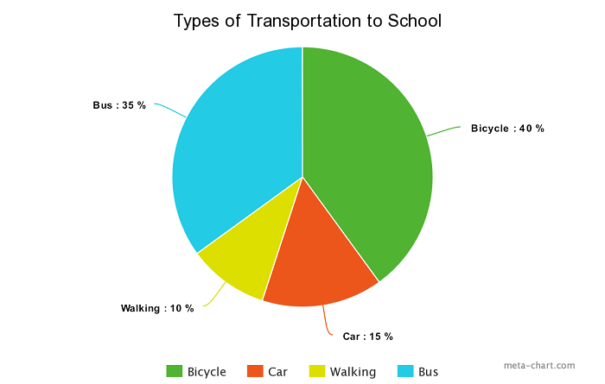

Pie charts are widely used by [data-driven marketers](http://intellspot.com/data-driven-marketer/) for displaying marketing data.

**4. Histogram**

A histogram shows continuous data in ordered rectangular columns (to understand what is continuous data see our post [discrete vs continuous data](http://intellspot.com/discrete-vs-continuous-data/)). Usually, there are **no gaps** between the columns.

The histogram displays a frequency distribution (shape) of a data set. At first glance, histograms look alike to bar graphs. However, there is a key difference between them. Bar Chart represents categorical data and histogram represent continuous data.

Histogram Uses:

* When **the data is continuous**.
* When you want to represent the shape of the **data’s distribution**.
* When you want to see whether the outputs of two or more processes are different.
* To summarize **large data sets** graphically.
* To communicate the data distribution quickly to others.

Example:

The histogram below represents per capita income for five age groups.

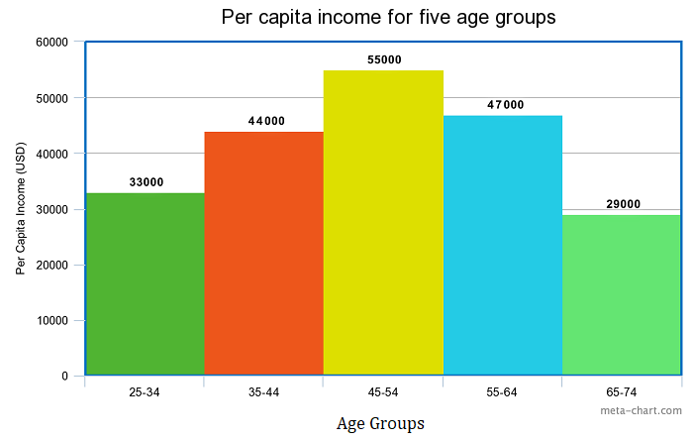

Histograms are very widely used in statistics, business, and economics.

**5. Scatter plot**

The scatter plot is an X-Y diagram that shows a relationship between two variables. It is used to plot data points on a vertical and a horizontal axis. The purpose is to show how much one variable affects another.

Usually, when there is a relationship between 2 variables, the first one is called independent. The second variable is called dependent because its values depend on the first variable.

Scatter plots also help you predict the behavior of one variable (dependent) based on the measure of the other variable (independent).

Scatter plot uses:

* When trying to find out whether there is a **relationship between 2 variables**.
* **To predict**the behavior of dependent variable based on the measure of the independent variable.
* When having paired numerical data.
* When working with [root cause analysis tools](http://intellspot.com/root-cause-analysis-tools/) to identify the potential for problems.
* When you just want to visualize the correlation between 2 large datasets **without regard to time**.

Example:

The below Scatter plot presents data for 7 online stores, their monthly e-commerce sales, and online advertising costs for the last year.

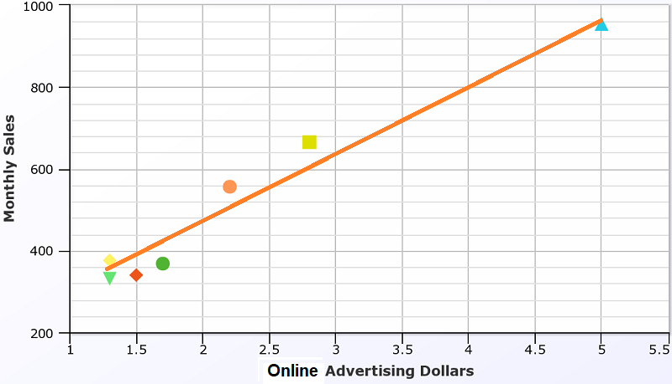

The orange line you see in the plot is called “line of best fit” or a “trend line”. This line is used to help us make predictions that are based on past data.

The Scatter plots are used widely in data science and statistics. They are a great tool for visualizing [linear regression models](http://intellspot.com/linear-regression-models/).

More examples and explanation for scatter plots you can see in our post [what does a scatter plot show](http://intellspot.com/scatter-plot/) and [simple linear regression examples](http://intellspot.com/linear-regression-examples/).

**6. Venn Chart**

Venn Diagram (also called primary diagram, set diagram or logic diagrams) uses overlapping circles to visualize the logical relationships between two or more group of items.

Venn Diagram is one of the types of graphs and charts used in scientific and engineering presentations, in computer applications, in maths, and in statistics.

The basic structure of the Venn diagram is usually overlapping circles. The items in the overlapping section have specific common characteristics. Items in the outer portions of the circles do not have common traits.

Venn Chart Uses:

* When you want **to compare and contrast** groups of things.
* To categorize or group items.
* To illustrate **logical relationships** from various datasets.
* To identify all the possible relationships between collections of datasets.

Example:

The following science example of Venn diagram compares the features of birds and bats.

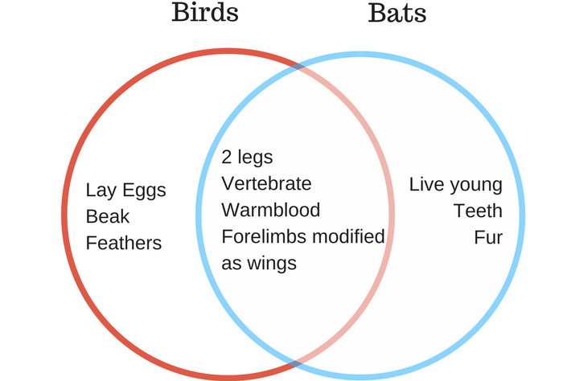

**7. Area Charts**

Despite line and area charts support the same type of analysis, they cannot be always used interchangeably. Line charts are often used to represent multiple data sets. Area charts cannot show multiple data sets clearly because area charts show a filled area below the line.

Area Chart Uses:

* When you want **to show trends**, rather than express specific values.
* To show **a simple comparison** of the trend of data sets over the period of time.
* To display**the magnitude** of a change.
* To compare a small number of categories.

The area chart has 2 variants: a variant with data plots overlapping each other and a variant with data plots stacked on top of each other (known as **stacked area chart** – as the shown in the following example).

Example:

The area chart below shows quarterly sales for product categories A and B for the last year.

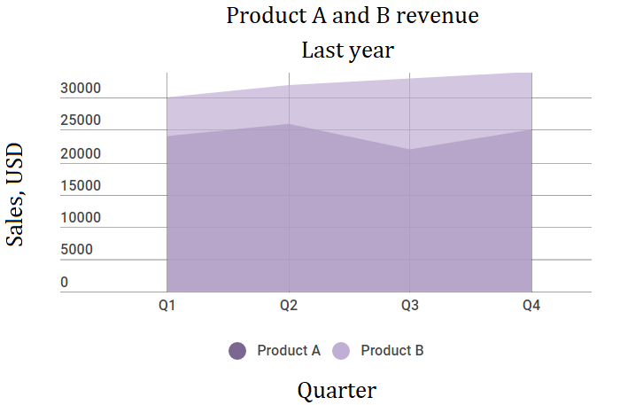

This area chart shows you a quick comparison of the trend in the quarterly sales of Product A and Product B over the period of the last year.

**8. Spline Chart**

The Spline Chart is one of the most widespread types of graphs and charts used in statistics. It is a form of the line chart that represent smooth curves through the different data points.

Spline charts possess all the characteristics of a line chart except that spline charts have a fitted curved line to join the data points. In comparison, line charts connect data points with straight lines.

Spline Chart Uses:

* When you want to plot data that requires the usage of curve-fitting such as**a product lifecycle chart** or an impulse-response chart.
* Spline charts are often used in **designing Pareto charts**.
* Spline chart also is often used **for data modeling** by when you have limited number of data points and estimating the intervening values.

Example:

The following spline chart example shows sales of a company through several months of a year:

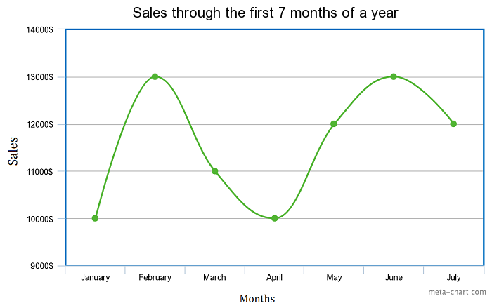

**9. Box and Whisker Chart**

A box and whisker chart is a statistical graph for displaying sets of numerical data through their quartiles. It displays **a frequency distribution** of the data.

The box and whisker chart helps you to display the spread and skewness for a given set of data using the five number summary principle: minimum, maximum, median, lower and upper quartiles. The ‘five-number summary’ principle allows providing a statistical summary for a particular set of numbers. It shows you the range (minimum and maximum numbers), the spread (upper and lower quartiles), and the center (median) for the set of data numbers.